Data Analytics – Final Project

Impact of Remote Work on Employee Mental Health and Productivity



Project Title:
"Impact of Remote Work on Employee Mental Health and Productivity"

Dataset Links:
- Source: Kaggle - Remote Work & Mental Health
- Raw Dataset Link - Remote Work & Mental Health Raw Data
- Cleaned Dataset Link : Remote Work & Mental Health Cleaned Data
- Google Colab Link: Google Colab Link
- Power BI Dashboard PDF Link: Power BI Dashboard Pdf

Stage 4: Documentation, Insights and Presentation:
  - Power BI Dashboard Link:
    - PDF Link: Power BI Dashboard Pdf

Power BI Dashboard Screenshots:
Dashboard 1:
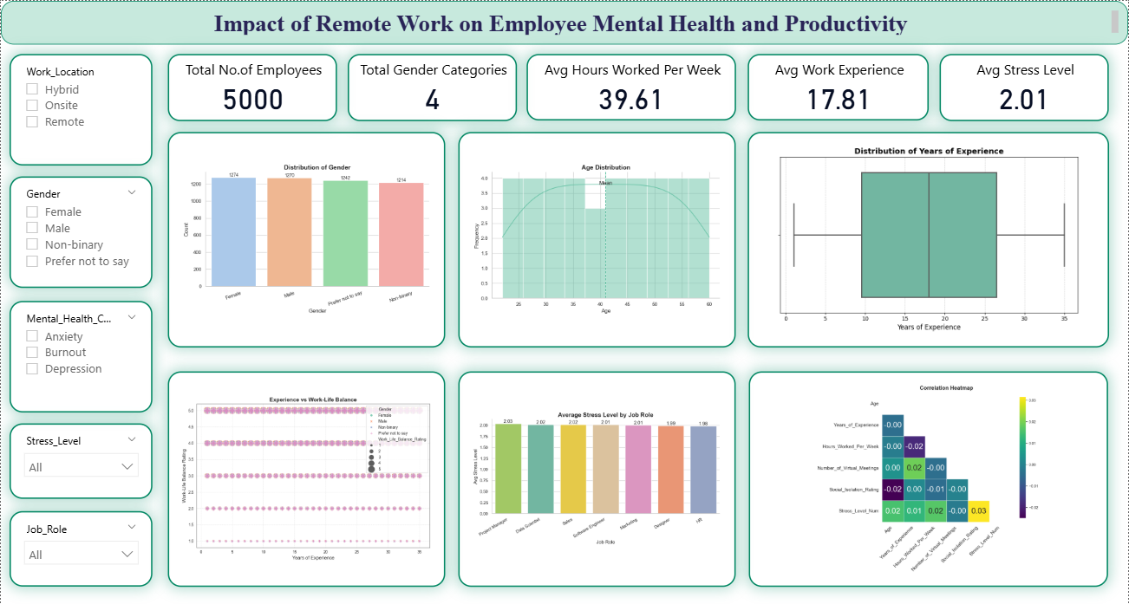

Dashboard 2:
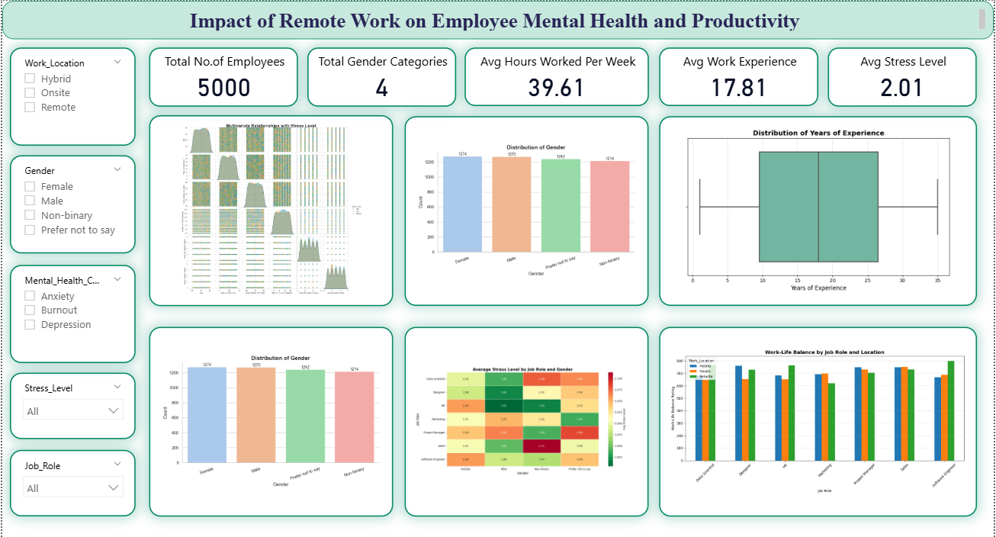
Dashboard 3:
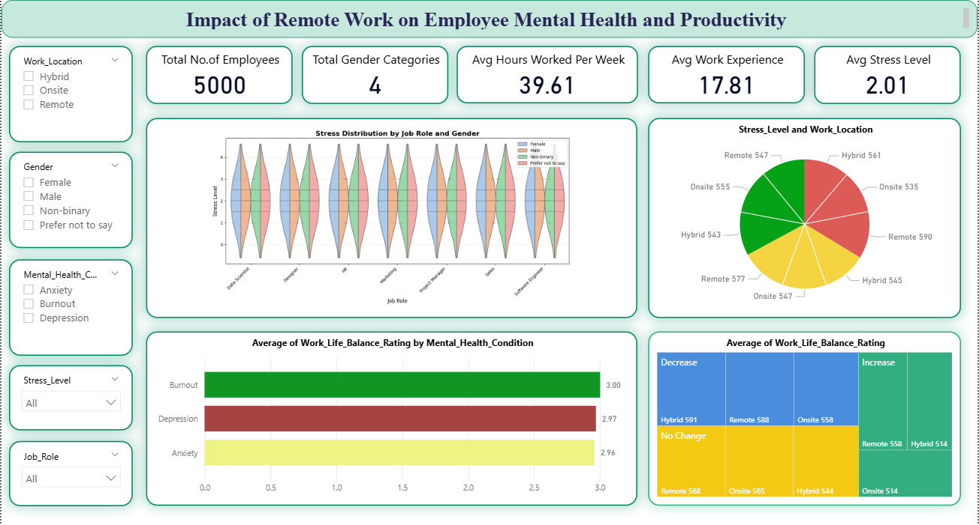
  - Findings (Summary):
The dashboard likely shows that remote work is a double-edged sword:
- It improves productivity at first (less commute, more flexibility).
- But over time, mental health declines for many employees (stress, isolation).
- When mental health drops, productivity eventually suffers too.
- The experience isn’t the same for everyone—work environment and communication make a big difference.

  - Key Insights:
- Productivity rises, then stabilizes or dips
- Early remote work → higher output
- Later → plateau or decline

Meaning: Gains are real but not sustainable without support

- Mental health shows a downward trend for some groups
- Increased stress, burnout, or disengagement in parts of the workforce

Meaning: Remote work quietly increases psychological strain

3. Strong link between mental health and productivity
- Employees with better well-being → consistently higher performance
- Poor mental health → lower output

Meaning: Well-being directly drives performance

4. Home environment creates inequality
- Dedicated workspace → better outcomes
- No proper setup → worse productivity + more stress

Meaning: Not all employees benefit equally from remote work

5. Communication gaps reduce engagement
- Lower collaboration/interaction → lower satisfaction and output

Meaning: Remote work fails when teams feel disconnected

  - Business Recommendations:
- Prioritize mental health (not just output)
- Offer counselling, mental health days, flexible schedules
- Train managers to identify burnout early
Why: Productivity depends on it long-term
- Move to hybrid work models
- Combine remote + in-office days
Why: Balances flexibility with social interaction
- Improve communication systems
- Regular check-ins, team meetings, async tools
Why: Keeps employees engaged and aligned
- Support home office setup
- Provide stipends for desks, chairs, internet
Why: Reduces inequality in performance
- Track well-being alongside performance
- Don’t just measure output—track stress, engagement, satisfaction
Why: Prevents hidden burnout
  - Final Story:
Remote work boosts productivity in the short term, but without the right support systems, it gradually harms mental health—which in turn reduces productivity. The best outcomes happen when companies actively support employees through good communication, flexible policies, and proper work environments.

